**PROGRAM [8]:**

P = 'P'

Q = 'Q'

R = 'R'

kb = [

(P, "=>", Q),

(Q, "=>", R),

(P,),

]

def is_true(sentence, model):

if sentence[0] == 'not':

return not is_true(sentence[1], model)

elif sentence[0] in model:

return model[sentence[0]]

elif len(sentence) == 1:

return False

elif sentence[1] == 'and':

return is_true(sentence[0], model) and is_true(sentence[2], model)

elif sentence[1] == 'or':

return is_true(sentence[0], model) or is_true(sentence[2], model)

elif sentence[1] == '=>':

return not is_true(sentence[0], model) or is_true(sentence[2], model)

elif sentence[1] == '<=>':

return is_true(sentence[0], model) == is_true(sentence[2], model)

def is_model_satisfies_kb(model, kb):

for sentence in kb:

**OUTPUT [8]:**

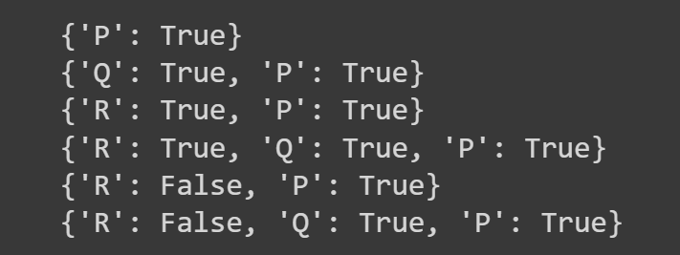

if not is_true(sentence, model):

return False

return True

def generate_models(symbols):

if not symbols:

return [{}]

else:

symbol = symbols[0]

rest = symbols[1:]

models = []

for model in generate_models(rest):

models.append(model)

models.append({**model, **{symbol: True}})

models.append({**model, **{symbol: False}})

return models

symbols = [P, Q, R]

models = generate_models(symbols)

for model in models:

if is_model_satisfies_kb(model, kb):

print(model)